There are so many BP debate resources out there in the aether, so I don’t really know why I’m adding to the clutter. However, I think sometimes all these resources can be overwhelming if you don’t know where to start, and then you end up wasting your time in a blackhole of random shit. I had no real idea wtf BP was until my 3rd year of college (and even that is debatable). So, if you are new to BP & lazy & generally ignorant about a lot of global topics, then this is the guide for you.
This document was primarily made for UChicago novices, but maybe you got your hands on the link somehow (?). In any case, here is a very non-comprehensive list of things you can do to kickstart your prep journey. To not overwhelm people, I tried to limit it to a few resources per category.
This document is not actually finished so if you want to yell at me you can DM Helen Wu on Messenger.

Learning the Basics
If you want to build a strong foundation from the ground up, I would recommend working through the below resources. It might be a pain, but I think learning the foundations of argumentation is more helpful than scattered attempts at improving, especially if you don’t have a BP/World Schools background:
- CDS Summer BP Practice Plan
  - 10 week practice plan made for the UChicago WUDC team
- Summer Workshops Resources ***Very good
  - Ryan Lafferty’s workshop series: I highly recommend watching his 9 video lectures from start to finish to improve very quickly. You can also read his doc Thoughts on BP
- Buildacase ***Very good
  - Matt Aydin’s website with a comprehensive BP improvement plan – includes drills & 10 total lectures. You can follow this over the course of 2-3 months

Written References
List of Upcoming Tournaments: Global Debating Spreadsheet
Motions:
- Debate Data List of motions at major tournaments by category
- Debating_Motions Spreadsheet with log of motions on Hello, motions (now defunct?)
BP Terminology:
- Debate Terms Glossary!! Level: beginner
- Debater's Glossary Level: intermediate - advanced
Resource Compilations
- CUSID Debaters Masterfile v.1.0
  - CUSID’s very helpful comprehensive reference document: reading materials, training vids (e.g., strategy, speech fulfillment, topic lectures)
- Novice Debate Resources.
  - Hart House novice debate resources: motions, speeches, terminology, case prep
- Debate Resources Compilation
  - Huge compilation of resources, videos, links. See pg 1 for beginner fundamental vids!
Intro to BP Primers:
- Introduction-to-British-Parliamentary-Debating.pdf
  - Level: beginner | Very short briefer of the rules of BP debate (12 pages)
- Cambridge_schools_bp_debating_guide_2013.pdf
  - Level: beginner | Short briefer of the fundamentals of BP debate (23 pages)
- Winning Debates - A guide to Debating in the Style of the World Universities Debating Championships - Steven Johnson.pdf
  - Level: intermediate | In-depth guide to advanced tactics, strategy, principles (271 pages)
FB Groups: Join Debate Seriousposting for helpful threads about improvement. Unless you want to fall into a pit of degeneracy, most other FB groups are either random memes or dead. So don’t join those.

Video Lectures
Note that CUSID Debaters Masterfile v.1.0 has a far more comprehensive list of all video lectures, but I will flag a few that I found most helpful for my own individual improvement. I personally did not have time to watch 1000 videos, so I find it most helpful to prioritize depth over breadth (ie: choose 2-3 lectures, try to integrate their advice over a long period of time)

Argument & Case Construction
- Noam Dahan - PM Speeches
- Structuring Arguments - Advanced Training Debate Workshop: Week 2
- Burdens of Proof by Hadar Goldberg
- First Speeches (PM/LO & Extension) - Advanced Training Debate Workshop: Week 6
- Building Arguments (Novice) - Miloš Marjanović. MDA
- RECONCEPTUALIZING PM SPEECHES WITH SAJID ASBAT KHANDAKER | Madrid WUDC 2023

Winning Strategy
- Belgrade WUDC 2022 Training Program: Winning Strategy with Harish Natarajan & Raffy Marshall
- Belgrade WUDC 2022 Training Program: Framing in Outrounds with Lee Chin Wee
- 'Advanced' Strategy in BP Debating
- Hamza Tariq Chaudhry - Advanced Argumentation

Deputies / Rebuttal
- REBUTTAL! BY MILOS MARJANOVIC | TRAINING ACADEMY EUDC MADRID 2021
- Deputy Speeches in Depth, with Duncan Crowe
- 2ND SPEECHES BY MATT HAZELL | TRAINING ACADEMY EUDC MADRID 2021
- Effective rebuttal, with Owen Mooney

Extensions
- How To Ease The Tension In Extension? - Charity Debate Workshop
- Tin Puljić - Extension Speeches
- EXTENTIONS BY NAOMI PANOVKA | TRAINING ACADEMY EUDC MADRID 2021

Whips
- Lucía Arce - Whip speeches
- Whip speeches, with Danny DeBois
- Arth Mishra - Whip Speeches
- Whip Speeches by Joseph Lewis

Random Stuff
- How to address spec knowledge motions when you don't know the topic by Hadar Goldberg
- Hadar Goldberg - Being comparative in debating

Matterfiling
Resources:
- Matter File.pdf Ryan Lafferty’s Vietnam WUDC Matterfile **very good
  - Ryan Lafferty’s (new) Panama WUDC Matterfile **very good
- Panama WUDC 24 Matterfile (Wu Jiang) (my matterfile)
- HOW TO MATTER PREP BY SARAH TAY| TRAINING ACADEMY EUDC MADRID 2021
What is a matter file? Matterfiling is basically just researching debate/global topics and writing it down in a consolidated doc. You can print out a matterfile and bring it to any tournament for rounds that require spec knowledge.
Why do it? One underrated part of improving is to just know more things about the world. I did not realize this fact until maybe 2 years into debating. I have a very bad short term memory, so I have to actually put in effort to remember things. Some people already know basic history / common knowledge / news by heart so they don’t have to matterfile as much. Still, you will probably do better in a debate about interest rates if you know what an interest rate is.
You should not just copy someone else’s matterfile. Half the point of making a matterfile is doing research yourself. Otherwise you could just bring an encyclopedia to a tournament and call it a day. For example, I printed out like 300pg of someone else’s matterfile for worlds 2 years ago and didn't use a page of it. This year I made my own 35pg matterfile and it was infinitely more helpful. Don't be stupid!
There are generally 3 forms of matter filing that I think are helpful:
- Basic historical knowledge: Broad geopolitical relations, history/government/economy of major nations, ethno-religious conflicts, international organizations, etc. (think AP World History shit, e.g. what happened in the middle east for the past 50 years?). Generally you only need to matterfile each country 1x. Knowing basic international relations helps you not look like an idiot and situates a lot of arguments in context.
  - Sources: any encyclopedia, CFR briefs, Wikipedia, ChatGPT, The Economist, other people’s matters files (lol), Youtube videos, etc.
  - Organization: Personally I have a small IR matterfile grouped by: region of the world → countries → government / economy / social issues / history / culture
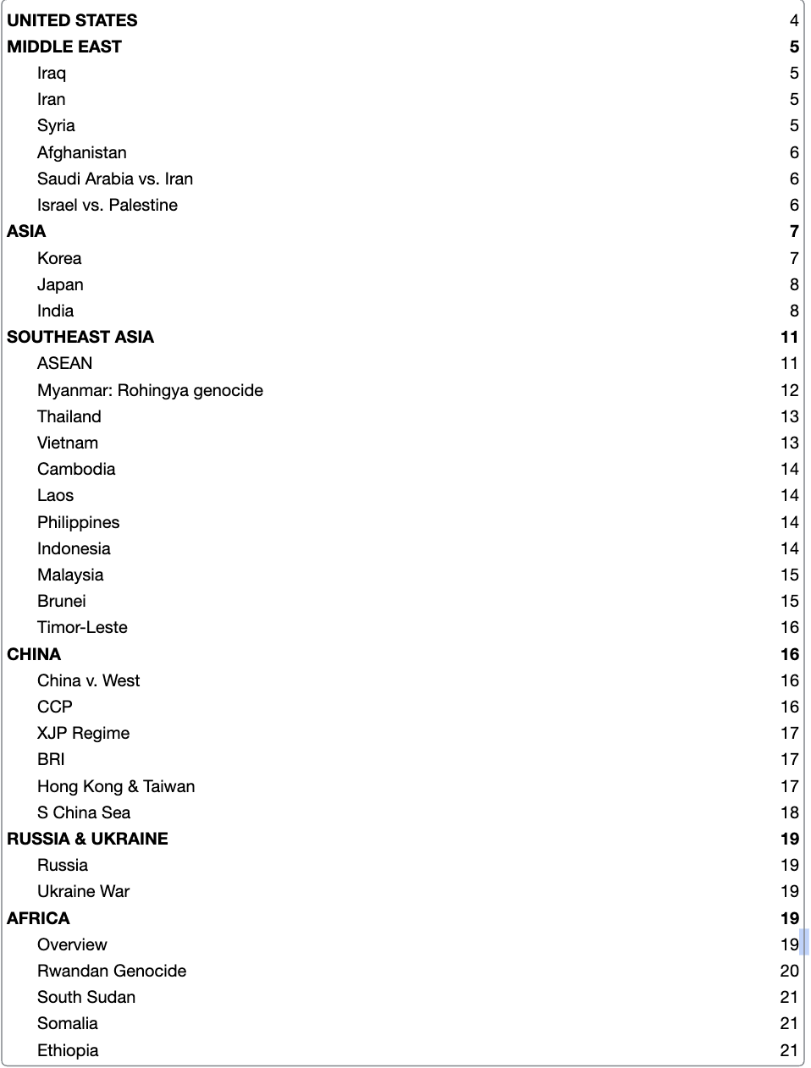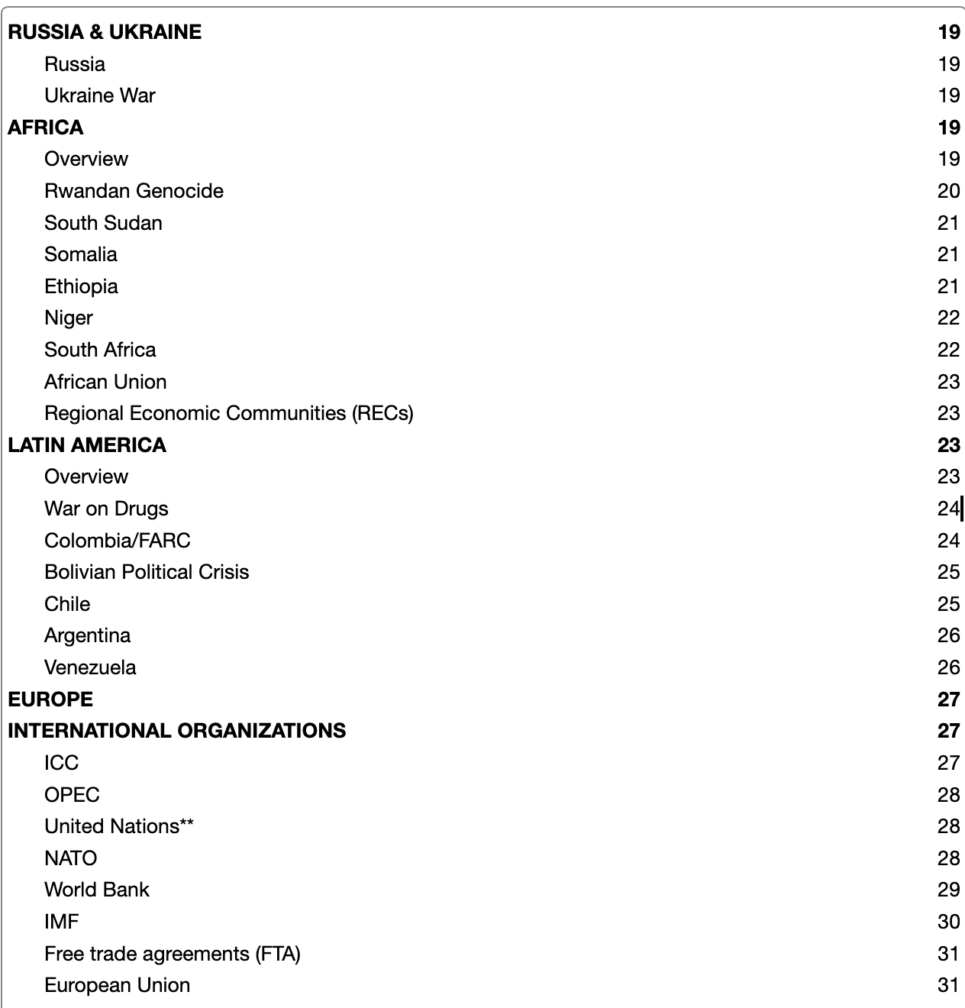
For reference, this was the extent of our pretty slim worlds matterfile, which I started like 3 days before flying out to Vietnam while in a hotel in las vegas and then illegally printed with a random hotel printer (i ran out of time & pretended that europe and US didn’t exist). But anyways the file actually saved us in multiple rounds about Japan, Vietnam, and India which I otherwise know nothing about :)

- Current news: major headlines, conflicts, social issues (think: Niger coup, COP28, Argentinian elections, etc.) Since most motions are about real life issues (wow), you should probably keep up with the news. This doesn’t mean you have to read The Economist on the toilet for hours each day, it could be whatever is most fun for you like tiktok. Personally I just listen to news podcasts and then I write down a 2-3 sentence summary of each episode on my Notes app.
  - Podcasts: NYT: The Daily, The Economist: The Intelligence, WSJ: The Journal
  - Email Newsletters: Chartr, The Daily Brew, WSJ Politics & Policy
  - Actual news websites: NYT, The Economist, Al Jazeera, etc.
- Debate stock arguments / case filing: beyond actual events, you probably want to familiarize yourself with common topic areas & mechs for/against stock args (think: finance, philosophy, religion, sports, tech, science, narratives). Keep a running doc of key mechs & extension ideas.
  - Sources: do a bunch of motions preps, Youtube topic lectures, watch good rounds
  - For topic area gaps: use topic specific websites (phil: plato.stanford.edu, econ: www.investopedia.com, etc. you get the point)

Debate Rounds
TBH there are just too many rounds out there to list out good ones to watch, so just defer to the resources below because I’m too lazy. You can watch any WUDC or HWS RR rounds or major tournament outrounds and they will probably be pretty decent.
- Debates Ryan Lafferty’s list of good parli rounds
- Debates to Watch Generally good debates
- Open BP Debate Resources See page 1 for specific speeches that are good
- If you want to find something specific, literally just search up that keyword in Debate Seriousposting FB group and there will be like 50 replies from debate sweats.

How to Watch Videos Productively without blowing your brains out
- If you are just starting out: Watch & flow ~5 rounds to get the gist of time organization & the role of each speaker. Rather than content, focus on structure. Don’t just flow the arguments, but rather the logical flow of each speech & time allocation.
  - Ex: Whip speech – 2 minute overview, 3 minutes on OG – number and types of rebuttal (mitigation, flip, weighing) – purpose of responses
- Intermediate level debaters: I don’t recommend just mindlessly watching rounds which I generally think is a waste of time. Instead, you should treat each video as an opportunity to learn, improve, and drill. Realistically, you could spend about 3 hours watching a single video across multiple days. There are a few ways I try to do this.
- Before watching: read the motion, do 15-minute prep of both sides. Force yourself to give a PM and record the speech. (DO NOT LOOK AT WHICH TEAM WON)
- After PM/LO: analyze which arguments & burdens you correctly identified/missed. If there is a topic weakness, add the mechs to your matterfile.
- If you deputy: Give a DPM and/or DLO as if you are in the round & record yourself. Analyze how your time allocation & strategy differed from the acc vid.
- After top half: Pause the video and brainstorm potential extensions for both sides. Flesh out the extension. If you’re feeling quirky, give the speech.
- If you whip: Give a gov and/or opp whip & record yourself. Figure out which teams are your largest threat, how you want to frame the extension, what rebuttal is most important, etc. Compare yourself to the acc whip and cry if you failed.
- After round: Give your call. Then compare to the actual call and figure out if you have shitty round vision. If you completely messed up, do some critical self reflection & wallow in self pity.
If you are feeling particularly bored, feel free to do all of the above steps but with your debate partner. It’s like a movie night but more cursed. Doing the motion preps / extension brainstorming / mock speeches together can build your partner dynamic and allow you to get feedback from a 2nd party.

Other Resources
- Debate Resources Compilation
- Open BP Debate Resources
- About Us — Eh Priori
- Guide to BP Book
- Training Materials | Warwick Debating Society
- Resources – Toronto Debate Academy
- Debating guides - Google Drive
- Training Materials | Warwick Debating Society
- How to Debate: Debating Resources Post Version 2 - Bigger, better and shinier
- 15minprep.pdf

Lmk if this was helpful or if you have any thoughts on additional stuff to add.

Also I don’t really know how widely this document is proliferating but i think it got added to some comprehensive novice resource doc so i am sorry if I offended anyone.

Again feel free to scream at me over messenger or email (helenwu@uchicago.edu). - helen

